A000-Am,C-Beheque with Headdress-Shell-1000 CE

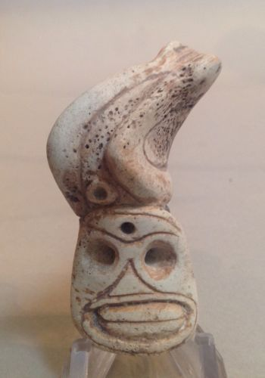

Am,C-Beheque with Headdress-Shell-1000 CE

**Case No.: 18**

**Accession No.**

**Formal Label:** Am,C-Beheque with Headdress-Shell-1000 CE

**Display Description:**

This expertly carved shell depicts a shaman in the whirlwind of a hallucinogenic experience, capturing the fury of the moment.

**LC Classification:**

**Date or Time Horizon: 1000 CE**

**Geographical Area: Caribbean**

**Map:**

**GPS coordinates:**

**Cultural Affiliation: Taino**

**Media: shell and ochre**

**Dimensions:**

**Weight:**

**Condition:**

**Provenance:**

**Discussion:**

**References:**